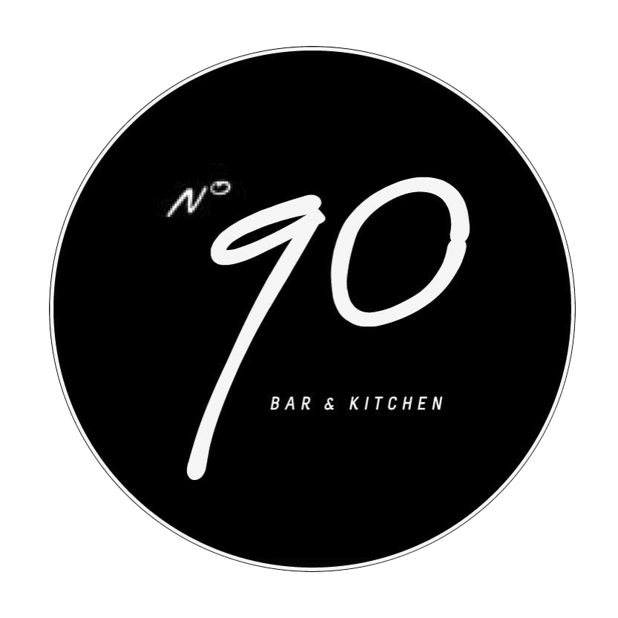

Be advised! Our food contains a LOT of love!
Starters
Sticky thai bbq’d lamb ribs, soy bean, coriander, red onion and thai flavours salad £6.5

Great Garnett’s Ham hock terrine, served with
pear chutney, San Francisco sour dough. £6.5

Meatball trio: beef and fennel, lamb and pistachio, pork and apple
Served with home-made ketchup £6.5

Smoked salmon, mixed leaf, pumpernickel and herb soft cheese £7

Lentil and quinoa salad. roasted pistachios, goat’s cheese mixed leafs and orange vinaigrette£6.5
Mains
Crazy biker’s mighty Burguer
8oz Irish Charolais, brisket & marrow burger, cheddar, tomato, red onion and lettuce served on a soft sesame and poppy seed bun and pickled gherkin £9
Add Bacon + 0.50
Add triple cooked hand cut chips + £2.50
Add sweet potato Fries + £2.00
Add skinny fries + £2.00
Add fried egg +0.50

Confit duck risotto, Roquefort, candied walnuts, green beans and balsamic reduction. £13

Braised ox cheek, roasted celeriac, glazed carrots and caper jus. £14

Linguini, beetroot, Seville orange vinaigrette, crispy kale and mascarpone £11

Thai style Welsh mussels & frites; chili, lemongrass and coconut milk. £12.5
Sides
Mixed leafs £3.5
Sweet potato fries £3.5
Hand cut chips £3.5
Steamed green beans £3
Sweets
Roasted caramelized banana, vanilla icecream, butterscotch sauce - £4
Crème caramel, orange tulle - £3.5
American Pancakes, nutella, rhubarb compote - £4.5
Icecreams £4
(Clotted cream, vanilla, chocolate chip & mint)
Sorbets: £3,5
(Mango, Raspberry)

All the animals featured in our menu lived a happy life!
E: info@90mainyard.co.uk
Follow us
Twitter: @number90_bar facebook: Number 90 Bar Restaurant

