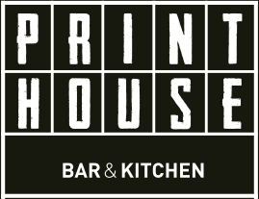

NOCELLARA OLIVES 3.50

HOMEMADE BROWN BREAD & BUTTER 2.50

STARTERS

SALAD OF MACKERAL, NEW POTATO, HORSERADISH & MIXED LEAVES 6.00 (C)

SMOKED SALMON & HADDOCK FISH CAKE WITH CHILLI SAUCE 6.00

WILD MUSHROOM & SMOKED CHEESE BRUSCHETTA WITH SLOW ROASTED BALSAMIC CHERRY TOMATOES 6.00 (V)

SOUP OF THE DAY WITH BRIOCHE 4.50

MAINS

BEER BATTERED HADDOCK, PEA PUREE, SMOKED PAPRIKA MAYO & HOUSE CHIPS 12.00

RISOTTO OF PEA, MINT & LEMON WITH WILD ASPARAGUS & SAUTEED GREENS 10.00 (V)(C)

SUNDAY ROASTS

(DUCK-FAT ROAST POTATOES, SAUTEE GREENS, CREAMED CELERIAC, HONEY GLAZED CARROT, GRAVY & YORKSHIRE PUDDING)

RARE BREED PORK BELLY 14.00

AGED TOPSIDE OF BEEF 14.50

BRAISED LAMB SHANK 14.00

GIANT YORKSHIRE WITH ALL THE TRIMMINGS (Veg Option) 14.00

SIDES (V) (C)

GARDEN SALAD 3.50/ MINTED BABY POTATO 3.5/
HOUSE CHIPS 2.50 (V)
(Paprika mayo 3.50)

(V) Vegetarian (C) Gluten free
Dishes may contain nut traces, please inform server of allergies

