TALK TO A MEMBER OF THE TEAM
TO BOOK YOUR TICKETS NOW!
ADULTS £16
CONSESSIONS £13.5
£1 from every ticket sold will be donated to our chosen charity
“SHOOTING STARS CHILDRENS HOSPICE”
~
PRE SHOW 4 COURSE DINNER
&
PERFORMANCE TICKET
ONLY £40
2 Bespoke Menus to Pre Order From

Pre – order essential for booking
Dinner will be served @ 530pm sharp

JOIN US HERE AT THE LINKS
WEDNESDAY AUGUST 24TH @ 7.30pm
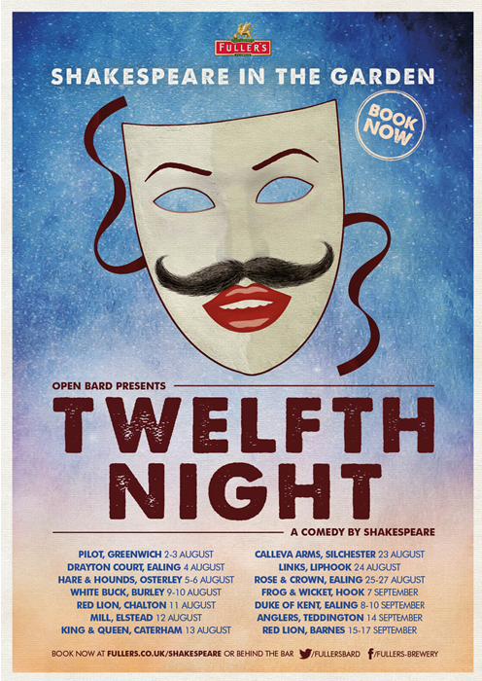
PRE - SHOW DINNER
SEBASTIEN’S MENU
CHEFS AMUSE BOUCHE
FOLLOWED BY
STARTER
TEA & HOP SMOKED HADDOCK CHOWDER
Mrs Owtons bacon, clams & golden pride sour dough
~
Main
BRASIED SHORT-RIB OF HAMPSHIRE BEEF
Truffle mash, salt baked carrots, roast shallots,
Curly kale & rich red wine jus
~
Sweet
MOCHA PANNACOTTA
Dark chocolate sauce & chocolate coffee beans

PRE - SHOW DINNER
VIOLET’S MENU
CHEFS AMUSE BOUCHE
FOLLOWED BY
STARTER
ORIENTAL DUCK SALAD
Confit duck leg, Asian vegetable medley, oriental dressing
~
Main
PAN ROAST MONKFISH
South coast mussels, Mrs Owtons bacon, lemon sauce
& crusty bloomer
~
Sweet
ICED HAMPSHIRE STRAWBERRY PARFAIT
Lavender doughnuts, macerated strawberries

