The Aviary Bar - Elvis Night “All American” Menu

Starters

Kentucky Rain Southern Fried Chicken
with Blue Cheese Dip

In the Ghetto Loaded Potato Skins [v]
Sweet Potatoes filled with Veggie Chilli, Chunky Guacamole & Tomato Salsa

All Shook Up Nachos [v]
Tortilla Chips, Tomato Salsa, Chunky Guacamole, Sour Cream and Cheese

***

Mains

Love Me Tender Cheese Burger
Homemade Beef Patty, Cheese, Fresh Tomato, Lettuce, Yellow Mustard & Mayonnaise

The Hound Dog
Frankfurter & Fried Onions – add Red Sauce, Yellow Mustard & Pickles to suit

Always on My Mind Mac N Cheese [v]
Creamy, Cheesy, Hot and Delicious!

***

Sides
Traditional ‘Slaw [v]
Onion Rings [v]
French Fries [v]
Corn on the Cob [v]

***

Desserts
Key Lime Pie [v]
Sweet Waffles with Maple Syrup & Ice Cream [v]
Chocolate Brownie [v]

***
£55 per person

You Can Choose:
1 Starter
1 Main
2 Sides
1 Dessert
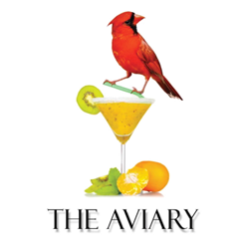
Includes a bottle of American Beer or a Glass of Wine

