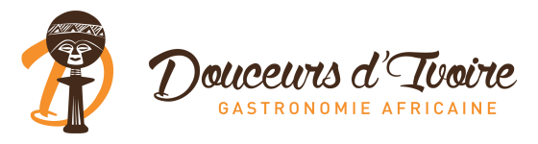

MENU

Amuse-bouche:

The yellow velvet verrine is composed of a tasty spiced plantain velouté

Starter (Congo):

The “kitoko” salad
made from Safou fruit & chicken

Main dish (Cote d’Ivoire):

Creamy yam & plantain gratin
Smoked mackerel fish served with a flavoursome tomatoes African aubergines sauce.

Dessert (Kenya):

The Wali, a coconut rice pudding topped with a crunchy grilled coconut & caramel opaline

