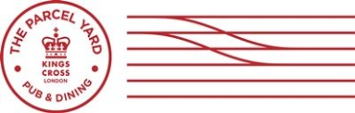

parcelyard.co.uk@theparcelyardtheparcelyard
 | BREAKFAST
Full English Breakfast |  |  | £9.50
Full Vegetarian Breakfast |  |  | £8.50
Porridge, honey |  |  | £3.75
Eggs Benedict Or Royal |  |  | £8.50
Eggs Florentine |  |  | £7.50
Breakfast Bap |  |  | £5.95
Bacon Bap |  |  | £3.95
Smoked Salmon, scrambled eggs, toast |  |  | £7.50
Grilled Halloumi, roasted vegetables, toast |  |  | £5.95
Granola, yoghurt, mixed berry compote |  |  | £4.50
Toast, butter, jam |  |  | £1.75
Croissant |  |  | £1.75
Pain Aux Chocolat |  |  | £1.75
Home Baked Brioche, jam |  |  | £1.75
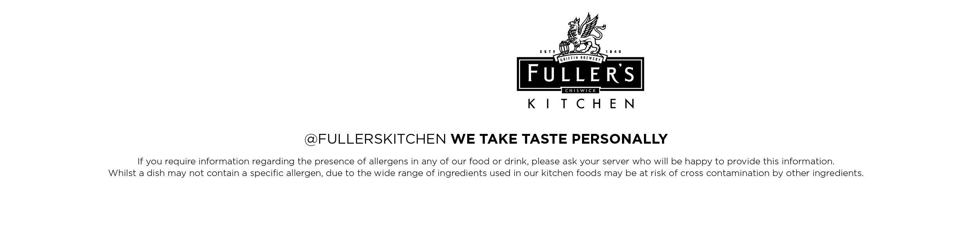

Rachid Messaoudi, Head Chef
The Parcel Yard

