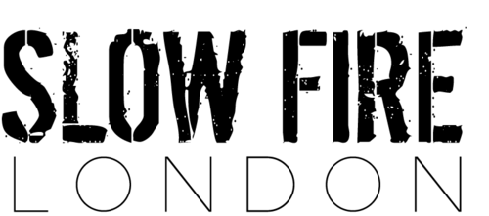

Small plates
Sweet potato fries -£3.5(v)
*
Skin-on potato fries -£3.5(v)
*
Jalapeño cornbread -£3.5(v)
*
Monterey Jack & chive hush puppies & remoulade sauce -£4(v)
(cheese & chive fritters)

Po Boys
Cajun beef brisket, pickles & chipotle slaw -£8.5
*
Bourbon braised jackfruit & sautéed bell peppers -£7(v)
*
Blackened Pollock, iceberg lettuce & remoulade sauce -£8
*
Buttermilk fried chicken & chipotle slaw -£8

Pots
Chicken & Andouille sausage Gumbo -£10
(classic Louisiana style stew served over rice)
*
Crawfish & blue crab Étouffée £12
(traditional creole shellfish stew served over rice)
*
Okra & tomato Gumbo -£8(v)
(served over rice)
*
Cajun mac n cheese-£8

Sweets
Chocolate & passionfruit cheesecake -£4.5
*
Banana Foster with praline brittle & caramel sauce -£4.5
(caramelised bananas, vanilla ice cream & rum toffee sauce)

