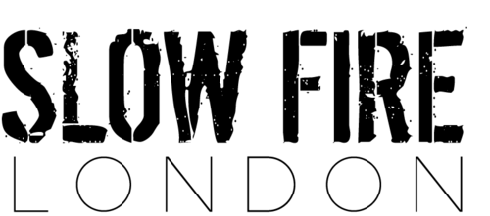

Mains
*
Slow Fire cheese & bacon burger £8 +foie gras £5
*
Hot & sour pork bun with Asian slaw & wasabi mayo £8
*
Grilled Cajun halloumi bun with sautéed peppers £7
*
Plumb smoked ribs, sweet potato mash & green chilli slaw £11.5
*
Smoked winter vegetable & barley salad £7 +hot smoked salmon £4
*
Smoked cauliflower cheese & crispy shallot rings £7 +bacon £1.5

Sides
*
Sweet potato fries £3.5
*
Skin on fries £3.5
*
Buttered kale £3.5
*
Sweet potato mash £3.5

Insta-slowfirelondon twitter-@slowfirelondon web-slowfirelondon.co.uk

