THE HYDRANT EVENING MENU
Meat and Fish board
Chorizo Scotch egg, chicken satay skewers, bbq pulled pork, frank’s hot wings, salt and pepper calamari, cod goujons.

Mezze Board
Chargrilled Halloumi, burnt aubergine dip, hummus, artichokes, Kalamata olive, marinated peppers, stuffed vine leaves, sweet potato falafel & flat bread.

Cured Meat Board
Salami Milano, beef pastrami, mortadella, marinated olives, pickles, smoked paprika hummus & chargrilled flat bread.
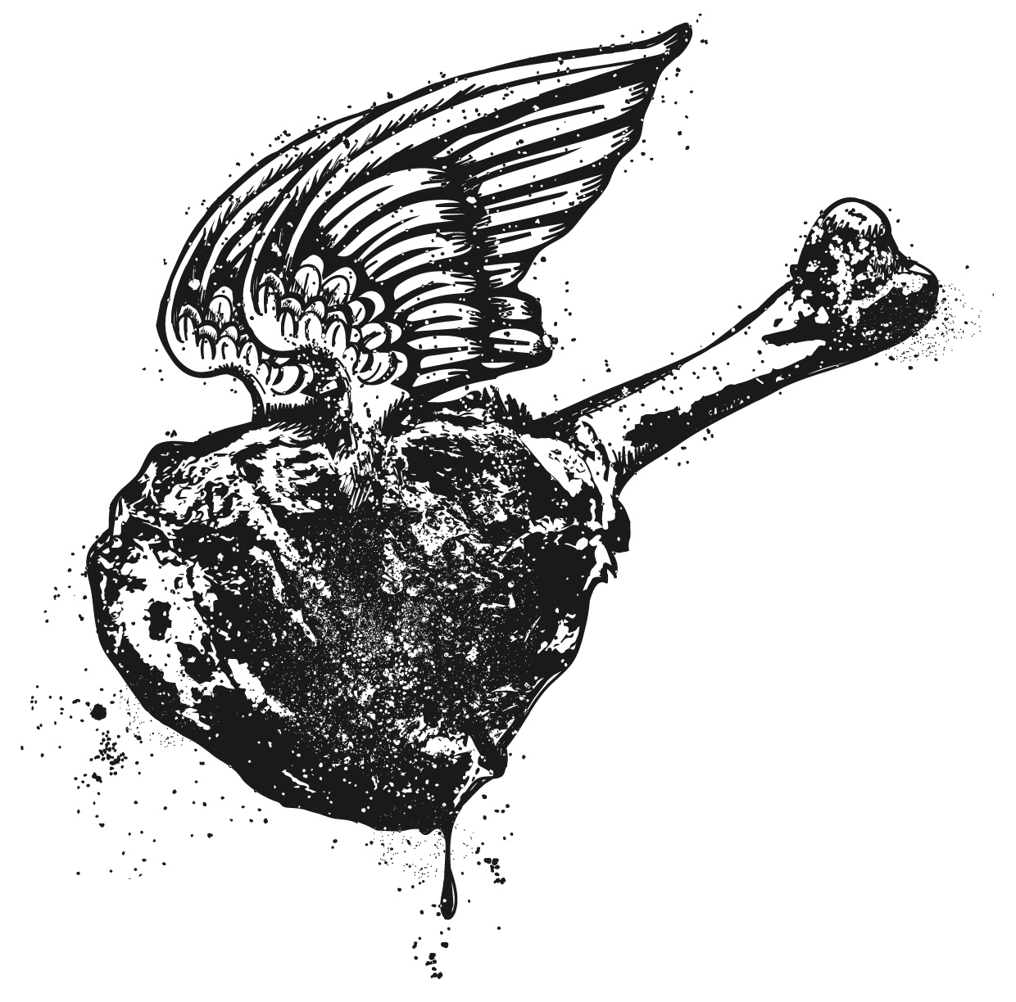
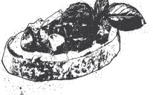
Add chips/salad £4

Each board feed 4-5 people
£30 per board

BAR SNACKS
House made chorizo Scotch egg
4
Rosemary salt chips
4
Hydrant hot wings, blue cheese dip
6.5
Nocellara olives and smoked almonds
6
Chilli nuts
2.5
Marinated Kalamata olives
2.5
Hydrant cheese board
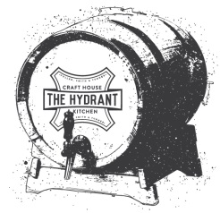
8.5

Buckets of craft beer available
Please speak to a member of staff for more information

