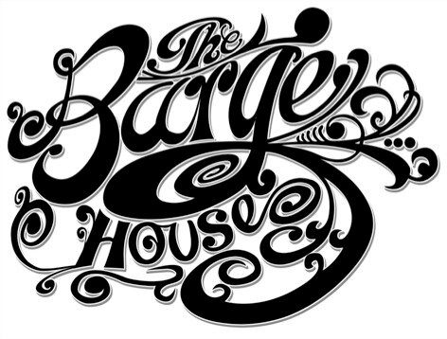

DINNER
6pm - 10pm

Starters

Padron Peppers (v) 4.5
Daily Soup with Sourdough (v) 6
Ham Hock Terrine, Pickled Cauliflower & Cornichons 8

Santos & Santos Spanish Charcuterie Board
- Salchichon Extra de Cerdo Iberico, Chorizo Bellota, Sobrassada, Morcilla Iberica, Jamon de Trevelez 9.5 / 18
La Fromagerie Cheese Board
- Bosworth Ash Log, Coulommiers, Le Cousin, Langres, Beauvale 9.5 / 18

Main

Cauliflower Steak with Pureē, Shallots & Brown Butter 13.5
Bean Stew with Carrot, Savoy Cabbage and Pistou 13
Fish of the day – see the board or ask your waiter 16.5
Bavette Steak with Cēpe Pureē, Confit Potatoes & Chervil 16.5
Venison with Celeriac, Broccoli & Red Wine Jus 15.5

Sides

Confit Potatoes with Aioli 4.5
Purple Sprouting Brocccoli 4.5
House Salad 4.5

Pudding

Chocolate Terrine with Chantilly Cream & Hazelnut Brittle 6
Lemon Tart with Mint Syrup & Crème Fraiche 6

Dishes may contain nuts and other allergens so please speak to a member of staff if you have a dietary requirement
A discretional 12.5% service charge will be added to your bill

THE BARGE HOUSE
Tues – Saturday 10am -11pm Sunday 10am-6pm
Weekend ‘Breakfast in Bread’ Brunch – Saturday & Sunday 10am-4pm
www.bargehouse.co.uk info@bargehouse.co.uk 020 7429 0765

