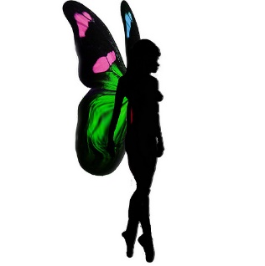
Enchanted Afternoon
Cocktail Tea
Arrival Cocktail
Dragon Tears
Prosecco and cherry liqueur

Unicorn
Prosecco, Gin & Elderflower

Savoury treats
Hunters Arrows
Chilli Garlic Chicken
Goblins Patch
Beef Sliders
Magic bean Stew
Bean stew
Butterfly sandwiches
Cheese and Ham
Cucumber
Enchanted forest patch
Avocado Caesar salad

Witches Brew
Vodka, Triple sec, Blue Curacao,

Sweet treats
Woodland berries
Berry mix
Magic wand
Marshmallow sticks
Magic mushrooms
Raspberry cupcakes
Unicorn Bar
Blondies

Angel wings
Elderflower Sugar Cookies
Fairy bites
Rose water sponge bites

Dark Lord shot
Nutella, Vodka &Milk

Magic Scones
Raisin scones
Garlic, Cheese $ Chive Scones

Forest Princess
Viniq, Cranberry and lemonade

