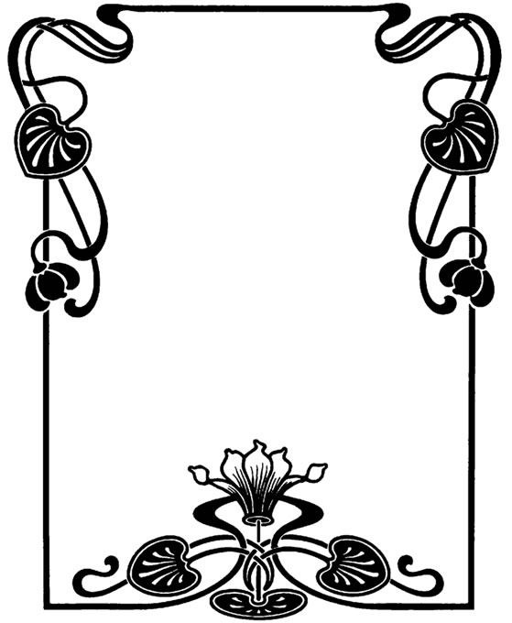 

**Appetizers**

Pastry Pigs in Blankets

Waldorf Salad

Spicy Meatballs

Cheese and Crackers

**Main**

Chicken Breast A’ La Rose

*Served with Mash Potato Cakes and a selection of veg*

**Dessert**

Mini Fruit Salad

Rose Water and Vanilla Sponge Bites

Mini Baileys Cheese Cake

**Great Gatsby Supper club Menu**





**Arrival Drink**

*Prosecco*

**Dinner Cocktail**

**Giggle Water**

*Prosecco, Gin and Elderflower*

**Dessert shot**

*Red Velvet*

