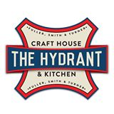

GIPSY HILL BREWING
BEER EVENT

4 SMALL PLATES
4 BEERS
£35

Buffalo mozzarella & slow roasted cherry tomato bruschetta, basil oil,
wild rocket & balsamic glaze
Southpaw Amber Ale/4.2%

Slow-braised pig cheeks, truffled Parmesan polenta,
sautéed spinach & crackling
Hepcat Session IPA/4.6%

Hot smoked salmon & beetroot salad, Anya potatoes, samphire,
caper berry & horseradish
Beatnik Pale Ale/3.8%

Chocolate mousse cake, raspberry sauce & clotted cream
Dissident English Porter/4.8%

