THE HYDRANT EVENING MENU
Meat and Fish board
Black pudding Scotch egg, Lamb kofta, Chorizo Croquettes, Hydrant hot wings, salt and pepper calamari, cod goujons.

Each board feed 3-4 people
£32 per board
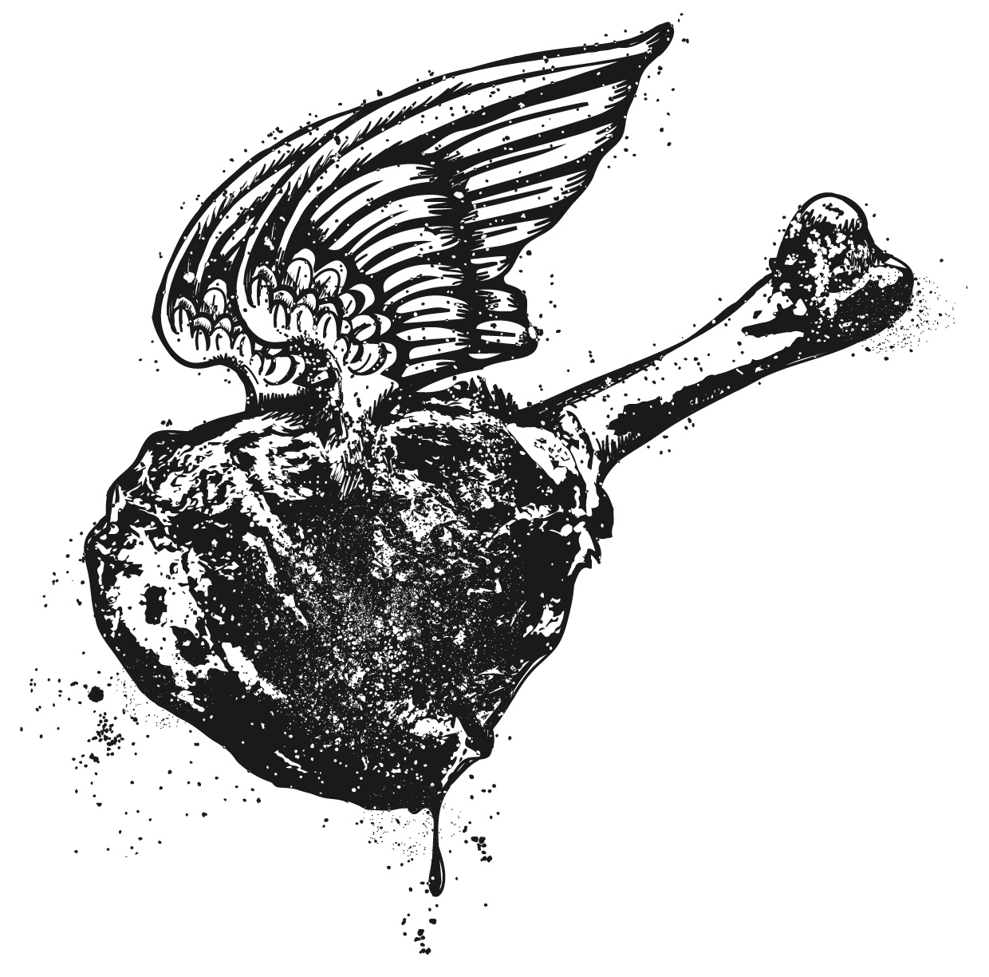

Mezze Board
Mozzarella sandwich, Greek olives, falafel, Potato and leek croquettes, grilled vegetables, baba ganoush, hummus, tzatziki & flat bread.

Each board feed 3-4 people
£27 per board
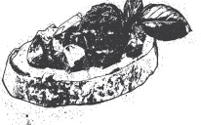
.

BAR SNACKS

Black pudding Scotch egg
5
Triple cooked chips
4
Peri peri hot wings
6.5
Chorizo and Red pepper Croquettes
5
Potato and leek croquettes
5
Salt and Pepper Calamari
7
Greek olives
3
Coleslaw
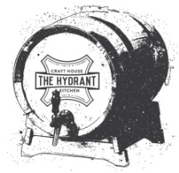
3.5

Buckets of craft beer available
Please speak to a member of staff for more information

