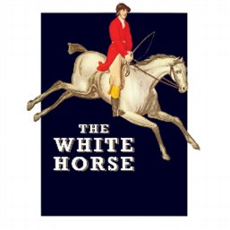
B A R S N A C K S
Hampshire Black Pudding Scotch Egg

Recommended beer – Montana Red
4.5
Salt & Pepper Squid
Paprika aioli
Recommended beer – Oliver’s Island
5.5
Tempura king prawns
Japanese mayonnaise
Recommended beer – Wild River
7
Flatbread

Red pepper hummus
Recommended beer - Frontier
4.5
S H A R E R S
Charcuterie
Chorizo, salami, Parma ham, gherkins, olives, bread 19
Wine Suggestion- Whistling Duck Chardonnay
Mezze platter
Hummus, babaganoush, olives, barrel aged feta, giant butter beans, flatbreads 17.5
Wine Suggestion- Riebeek Pinotage Rose
S I D E S
All 4
Chips
Rocket & aged parmesan salad
Buttered spring greens
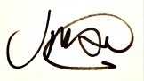
FACEBOOK, TWITTER & INSTAGRAM TheWhitehorseTW10

Head Chef
The White Horse

