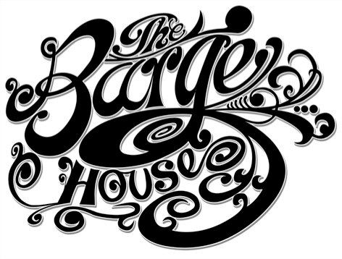

The Barge House Specials

English Garden 9
Hendricks Gin & St Germain Elderflower Liqueur, combined with Fresh Cucumber, Apple, Lemon, Mint & Sugar

Blackberry ’75 9.5
Prosecco with Fresh Blackberries, Reyka Vodka, Chambord & a dash of Lemon

Hemingway Daiquiri 9
White Rum shaken with Fresh Lime, Grapefruit & Maraschino Cherry Liqueur

Southern Kick 9
Monkey Shoulder Whisky, Lime, Mint and Homemade Chilli Syrup, topped
with Spicy Ginger Beer

Naughty Sailor 9
Sailor Jerry Rum, Lime, Pineapple & Chilli

Classics

Espresso Martini 8.5
Climpson and Sons Espresso shaken with Vodka or Rum &
Mr. Black Cold Brew Coffee Liquor & a touch of Sugar

Britz Spritz 10
Kamm & Sons, Prosecco & St-Germain Elderflower Liquor, topped with Soda

Sours 9
Lemon Juice, Sugar & Egg white shaken with your choice of Monkey Shoulder Whisky, Haymans Gin, ABA Pisco or Dasaronno Amaretto

Barge House Bijou 9
Haymans Old Tom stirred with Sweet Vermouth and a Hint of Green Chartreuse

Negroni & Aperitifs
Blood & Sand 9.5
Buffalo Trace Bourbon, Cherry Liqueur, Orange Juice, Martini Rosso &
Burnt Orange

Negroni Sbagliato 9
Prosecco, Sweet Vermouth and Campari with Seasonal Fruits

The French Lillet 9
Lillet Blanc stirred with Suze, Aperol & Lemon Twist

Berlinetta Boulevardier 9
Rye & Bourbon Whisky, Sweet Vermouth, Cynar & Orange Slice

Due to our licensing we serve alcoholic drinks from 11am

Bottled Beer

Brooklyn Lager 335ml 5.2% 5
Peroni Lager 330ml 5.1% 4.5
Ace of Spades, London Porter 330ml 4.7% 5.5
London Fields Brewery Hopster Pale Ale 330ml 4.2% 5
London Fields Brewery Broadway Boss, Pils larger 330ml 4.6% 5
London Fields Brewery 3 Weiss Monkeys White IPA 330ml 5% 5
Meantime. London Pale Ale. 4.3% 5.5
East London Brewery Peacock English Pale Ale 500ml 4.2% 6.2
East London Brewery Jamboree Golden Ale 500ml 4.8% 6.5
East London Brewery Cowcatcher American Pale Ale 500ml 4.8% 6.5

Draught Beer & Cider half/pint

Asahi Super Dry 5% 2.7/5.4
Pilsner Urquell 4.4% 2.5/4.9
Meantime. Helles Lager. 4.2% 2.5/4.9
Meantime. London Pale Ale. 4.3% 2.5/4.9
Session IPA 4.1% 2.5/4.9
Cote Breton Brut Cidre 4.5% 2.5/4.9

White Wines 175ml/btl

Réserve St-Vincent Grenache Blanc 5/20
Picpoul de Pinet 6.5/24
Lamelia Verdicchio di Metalica 6.25/25
Touraine Sauvignon 6.25/25
Cuvée de Brieu Viognier 7.5/28
Macon Davaye, Domaine des Maillettes 7.5/28
Albarino 8/30

Red Wines 175ml/btl

Reserve St-Vincent Merlot 5/20
De Chansac Carignan Vieilles Vignes 6/23
Les Muriers Pinot Noir 6.5/24
Beyra Tinto 7/28
Puro Malbec Cabernet 9/36
Pensamentu, Sardinia 10/45

Rose Wines 175ml /btl

Cinsault Vieilles Vignes Rare Vineyards Rose 6.5/26
Melopee de Gavoty Rose Provence 7.5/28
Nestuby Provence 7.5/36

Sparkling 125ml/btl

Galanti Prosecco 7/28
Piper Heidsieck Champagne -/70

