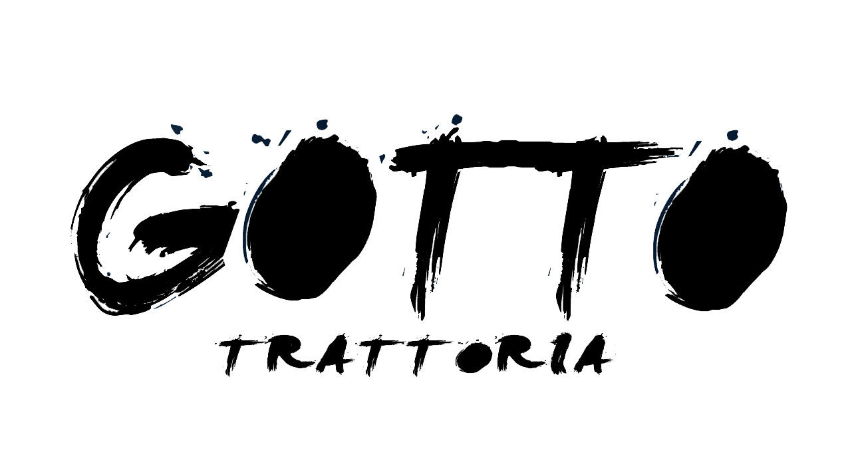

£25 CHRISTMAS MENU
Each person should order one main course and one dessert of their choice.
The antipasti will be shared around the table.

Sharing Antipasti
Courgette Fritters
Deep fried squid with lemon mayo
Burrata pugliese with roast squash, honey and walnuts gf
Venison meatballs, juniper berries and pecorino cheese
Mains
Tagliatelle with beef ragu gfo
Pumpkin risotto with radicchio veronese vo
Pizza Natale (tomato, mozzarella, artichoke, black olives, basil pesto and fresh ricotta cheese)
Pizza Saporita (tomato, mozzarella, black cabbage, salsiccia Napoletana and gorgonzola cheese)
Dolci
Zeppole with sultanas and cinnamon, Madagascar vanilla ice cream
Brandy affogato on Christmas Pudding ice cream with amaretto biscuit crumble

A discretionary 12.5% service charge will be added to your bill.
Vo – vegan optionional, gf - gluten free, gfo - gluten free optional. For any other allergen information please just ask.

Buon Natale!
Join us for Christmas all’Italiana
Take a look at our Christmas party menu or book your Pizza Party!
Starting from the 25th of November, available for lunch or dinner.

£15 PIZZA PARTY MENU

2 drinks each and 1 pizza between two for £15 per person.
Choose from draught Beer, Prosecco and Aperol Spritz.
Available on Ortolana or Diavola Pizzas.
Minimum 4 people.

Celebrate Christmas in Soho
in our sister restaurant
46 Brewer Street, Soho, London W1F 9TF
+44 020 7096 2096
info@ meleepere.co.uk
www.meleepere.co.uk

Instagram@meleeperesoho Facebook@MeleEpereTrattoria

