Maldon rock oysters (3)/(6) 9.0/18.0
shallot vinegar, tabasco & lemon (gf)
Crispy fried Maldon rock oysters (3) 10.5
cocktail sauce & gem lettuce
Maldon rock oysters (3) 9.5
basil oil & pickled cucumber (gf)

Salt cod croquettes (3) 6.0
aioli
Shell-on Atlantic prawns (200gr) 7.0
ancho chilli mayo (gf)
Cornish dressed crab, 15.0
house mayonnaise & sourdough (gf*)
Baked Rye Bay scallops (2) 9.0
thyme & parmesan crumb
Grilled Galician octopus 12.5
confit garlic, fresh chilli & mint salad (gf)
Chargrilled Cornish mackerel fillets 11.5
spiced tomato relish & parsley salad (gf)

Marinated tomato bruschetta 6.0
crispy shallots, tahini & lemon dressing (v/gf*)
Dorstone goats’ cheese 8.0
orange blossom honey, toasted walnuts (v/gf*)

Beer battered South Coast haddock fillet 14.0
triple cooked chips, mushy peas & tartare sauce
Whole Rye Bay plaice 14.0
brown butter & anchovy crumb (gf*)
Peterhead hake fillet 15.0
chickpea & pepper stew (gf)
Pan-fried sea bass fillet 13.0
braised lentils, chorizo & chilli
Rope grown Shetland mussels (600gr) 12.5
white wine, garlic, shallots, parsley & cream (gf*)
Slow roasted pork belly 15.0
grilled onion, crispy sage, fennel & apple sauce (gf)
Grilled polenta, roasted cauliflower 10.5
cauliflower creme, hazelnut dukka (gf/vg)

28-day aged beef burger 8.5
gherkins, ketchup & mustard
Fried halloumi burger 8.5
avocado & mint mayo (v)

Steakhouse fries 4.0
Sweet potato fries 4.0
New potatoes, herbed butter 4.0
Green salad 4.0

The Vic Shellfish Platter

Maldon rock oysters 6
Cornish dressed crab
Shell on Atlantic prawns 200gr
Shetland mussels 200gr
Rye Bay Scallop ceviche
40.00
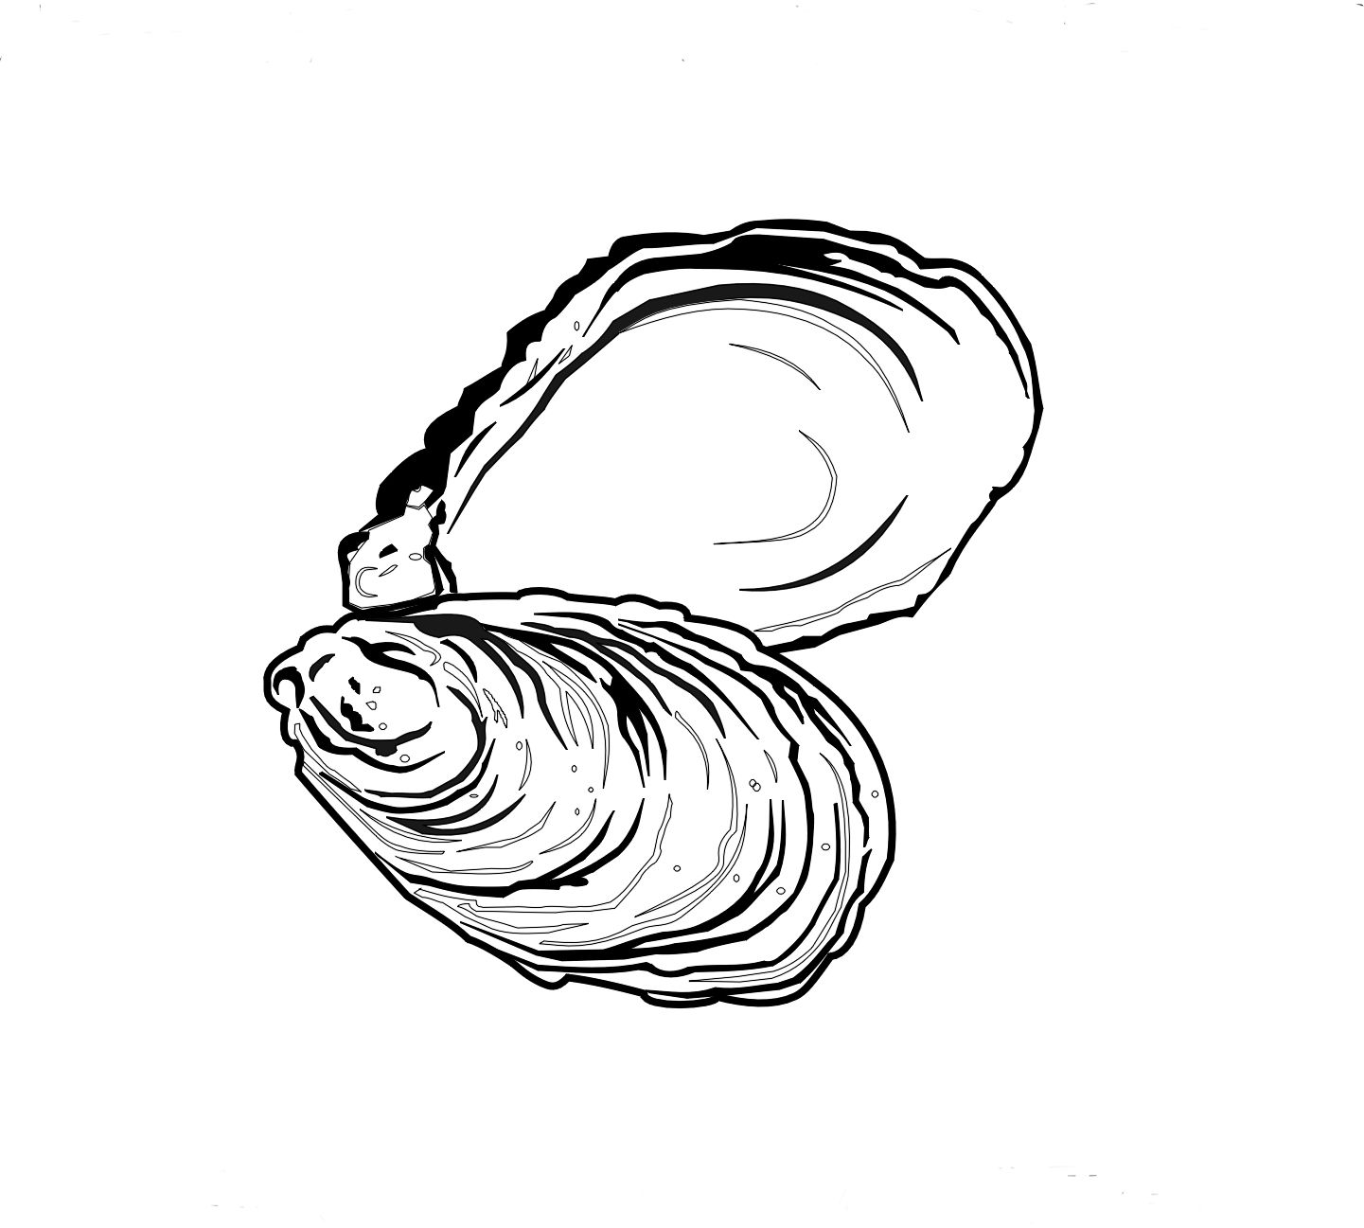

Dark chocolate mousse 6.5
salted caramel popcorn (v/gf*)
Layered vanilla cheesecake 6.5
blueberry compote
Vanilla ice cream 2.0
(scoop) (v/gf)
Lemon sorbet 2.0 (scoop) (vg/gf)

Espresso martini 9.0
Absolut vodka – Kahlua - Espresso
Muscat, Beaumes De Venise FR 75ml 5.25

SIGNATURE-COCKTAILS

Negroni Bianco 9.5
Beefeater gin – Luxardo Bianco – Dolin Vermouth
Magri’s Punch 9.25 Havana special – Homemade falernum – Pineapple - Lime Juice – Angostura bitters
Rhubarb & Raspberry Spritz 8.75
Havana 3 – Aperol – Raspberry & Rhubarb Sherbet -Grapefruit bitters – Pink grapefruit tonic
Juniper Fizz 8.75
Sipsmith Gin – Tonic Syrup – Noilly Prat –
Prosecco
Blueberry Spritz 8.75
Bombay Sapphire gin – Blueberry & lavender syrup - Lemon Juice – Rose Lemonade
Mandarin Fizz 8.75
Mandarin infused Absolut vodka – St Germain –
Sparkling elderflower tonic

