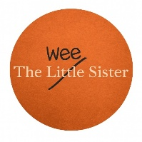

The Wee Sister Wine Bar Snack Menu
Sourced by Irish, Made by Irish

Designed and prepared to be simple, delicious, and perfect for enjoying with friends and family.

Chips / Fries £6

Irish Sourdough Freshly Made Bread & Irish Butter £6

Cocktail Sausages £6

Irish Charcuterie
Corndale Farm Cured Meats £8

Irish Cheese Board
Irish Farmhouse Cheeses, Crackers, Chutney £14

Salad
St. Tola Goats ‘Cheese, Pecan, Dressed Leaves £9 / £18

